**Team Name:** PetInsights

**List of all team members with majors and email addresses:**

* 1. Tosha Bapat Computer Science – [*bapatta@mail.uc.edu*](mailto:bapatta@mail.uc.edu)
  2. Pavni Bakhshi Computer Science – [*bakhshpi@mail.uc.edu*](mailto:bakhshpi@mail.uc.edu)
  3. Mailys Terrier Computer Science *–* [*terriems@mail.uc.edu*](mailto:terriems@mail.uc.edu)

**Faculty Advisor**

Nan Niu ([*niunn@ucmail.uc.edu*](mailto:niunn@ucmail.uc.edu)*)*

**Project Topic Area :**

* Web and App Development
* Software Engineering
* End-to-End Development (Full Stack)
* Customer-focused Application
* Giving back to the community

**Project Description :**

We would like to create a mobile application or a web-development application supporting local animal shelters (with the long-term goal to span out nationally). We would like to help both the adoption-seekers in finding the right pet for them, along with the animal shelters themselves in recruiting volunteers and getting the donation items they need.

Regarding the adoption-seekers, often we see cases where people return the animals they’ve adopted due to the pet being different than what they expected. For example, someone who wanted a calm dog for their kids returns a newly adopted one that ended up being highly energetic. Our application will tackle this issue by offering crowd-sourced feedbacks on the sheltered animals during interactions. The feedback may come from volunteers who walk the dogs or socialize with the cats, or from visitors who got the chance to interact with an animal they thought they wanted to adopt.

The below is an example where visitors have comments that this specific dog, Speckles, is playful, energetic, and not suitable for small children. Screenshot is taken from a demo I designed in Word.

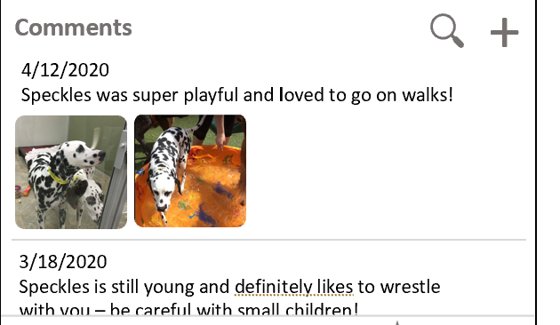

Regarding the animal shelters, I can see our application helping them in terms of recruiting volunteers and collecting donations. Shelters will be able to submit the items they are in need of, and users of the app will be able to search which shelters need what. When the shelters have received enough of a certain item, they can update the application and inform users to direct their items elsewhere.

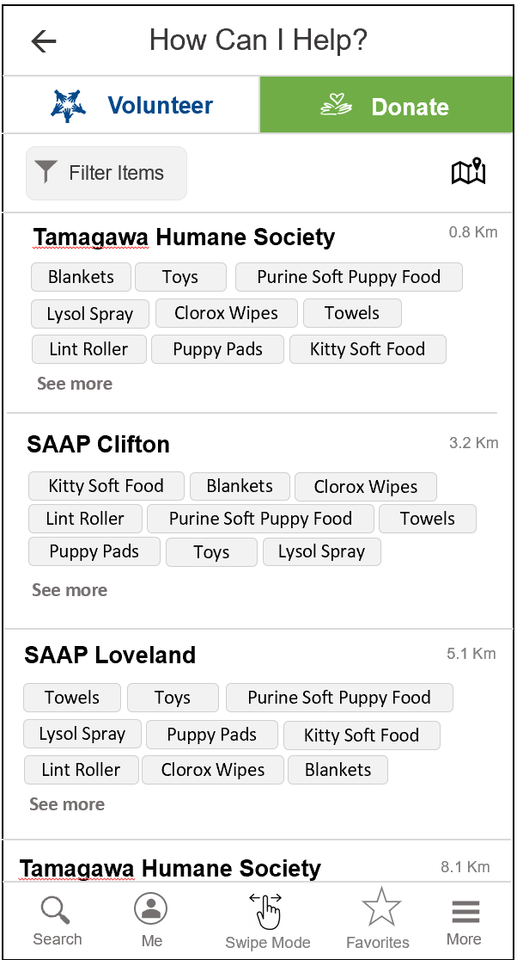

There will be two main views of the application.

1. User View: Users can search for an animal that matches their needs and give feedback on the ones they got the chance to interact with.
2. Shelters/Volunteers View: Representatives of the shelter or volunteers with access can update their information and review the feedback submitted on the animals.

Some additional technical details include:

* Account creation for users to help keep track of sheltered animals they’re interested in, with the possibility of notifying them when there’s been an update.
* Database storage of comments and images of sheltered animals

Our application would create an online, easy way to search for pets remotely (especially in the era of Covid-19) and help organizations in need. We plan to continue supporting and improving this application even beyond senior design.